**Lab 3**

**Name:-** Aryan Dilipbhai Langhanoja

**Date:-** 18-07-2023

**Enrollment No:-** 92200133030

**CO1: To write, test, and debug simple Python programs**

**CO2: To implement Python programs with conditional, loops and functions**

**Task 1:- Implementing Different String Methods**

**Python Code:**

a = "Aryan Langhanoja"

print(a[-4:])

print(a[3:8])

print(a.title())

print(a.istitle())

print(a.islower())

print(a.isupper())

print(a.find('l'))

print(a.rfind('a'))

**Output:**

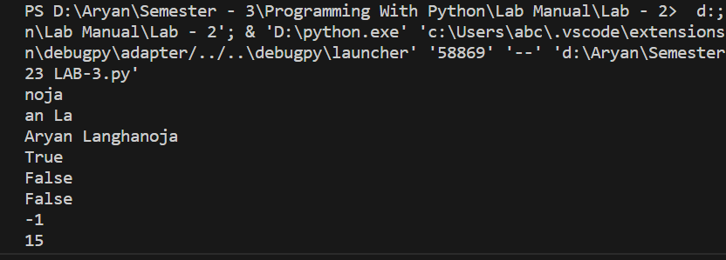

**Task 2:- Implementing Different String Methods**

**Python Code:**

y = " Aryan Langhanoja "

print(y.strip())

z = "Aryan Patel"

print(z.replace("Patel" , "Langhanoja"))

print(z.find('a'))

print(z.replace('a','b'))

print(z.index('a'))

print(z.rindex('a'))

**Output:**

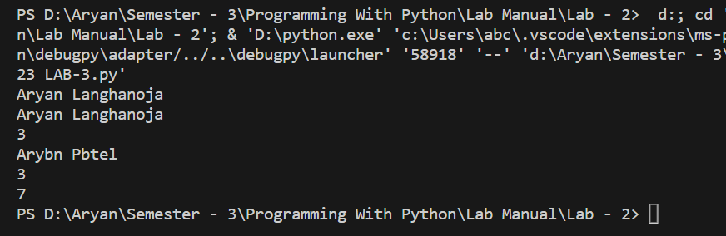

**Task 3:- Implementing Different String Methods**

**Python Code:**

num = '123'

alpha = 'Aryan'

alphanum = 'Aryan@123'

print(num.isnumeric())

print(alpha.isalpha())

print(alphanum.isalnum())

print(num.isdecimal())

**Output:**

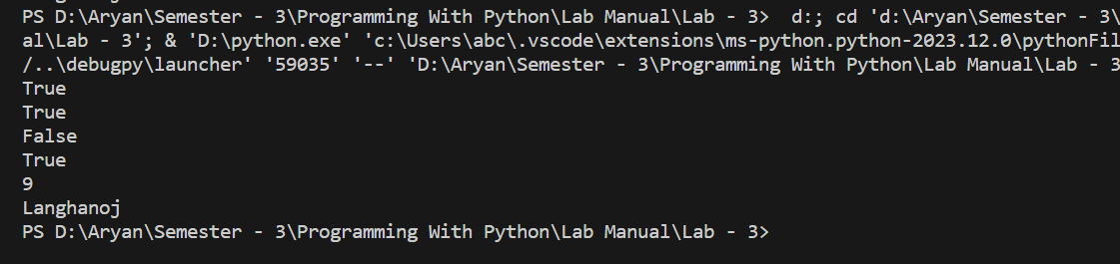

**Task 4:- Remove Repeating Character Once from a string**

**Python Code:**

A = "Langhanoja"

index = A.rfind('a')

list1 = list(A)

list1.pop(index)

result = ''

for i in range(0,len(list1)) :

result += list1[i]

print(result)

**Output:**

